Silicon Valley Forum of Famous Doctors （ Phase Two and Three）
硅谷名醫大講堂（第二、三期）
Approved CEUs: LAc: 32 credits, Category 1, Provider #378

硅谷醫學大講堂，由福特中醫大學舉辦，邀請美國和世界各地名中醫和學有專長的臨床醫生擔綱主講，目的是為全球中醫能工巧匠者搭建傳播平台。

第二期
演講嘉賓：黄国健博士
演講題目：迷你刃针疗法的临床应用
日期：2019年12月11-12日
地點：福特中醫大學東灣校區
報名：繼續接受報名，快速報名表見第4頁

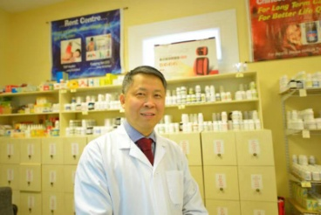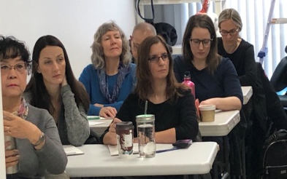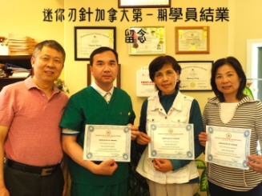
Instructor: Dr. Guojian Huang
Topic: Clinical Application of Mini -Ren Acupuncture Needle Therapy迷你刃针疗法的临床应用
Mini-Ren Needle Therapy is popular therapy throughout China. It is also being legally used by more and more acupuncturist in the US and the Canada. Dr. Guojiang Huang’ll discuss the theory and the practice of Mini-Ren Needles. About the theory, he’ll discuss the scar adhesion, the fascial pain point, the three dimensions, and the common muscle movement anatomy. About the practice, he’ll teach how to use the Mini-Ren to release multiple pain fast and effectively.
迷你刃针是新一代的针具，有针的刺激作用，也有刀的微切割作用。迷你刃针治疗疼痛的靶点主要有肌肉起止点处的深浅筋膜、皮下压痛性疤痕粘连结节、痉挛肌肉及其上的筋膜激痛点；迷你刃针的治疗深度一般不超过1公分，大部分在0.3-0.5公分，不会损伤到深层的主要大的血管神经等，是一种非常安全的针刀疗法。該針具在加拿大和美國合法應用。主講黄国健博士是迷你刃针疗法专家。协和医科大学博士，南京中医药大学本碩。北京中日友好临床医学研究所工作，加拿大马尼托巴大学医学院从事博士后。2005年在加拿大温尼伯开设安康中医药针灸康复中心至今。
第二期
演講嘉賓：魏媛自然療法醫師
演講題目：浮针中的精准肌肉运动（再罐注）
日期：2019年12月9-10日
地點：福特中醫大學東灣校區
報名：繼續接受報名，快速報名表見第4頁

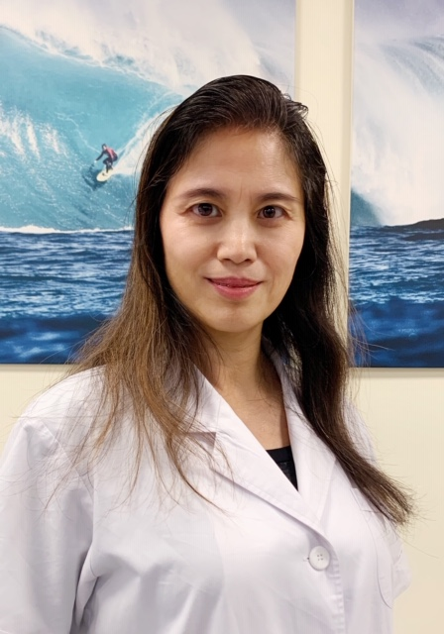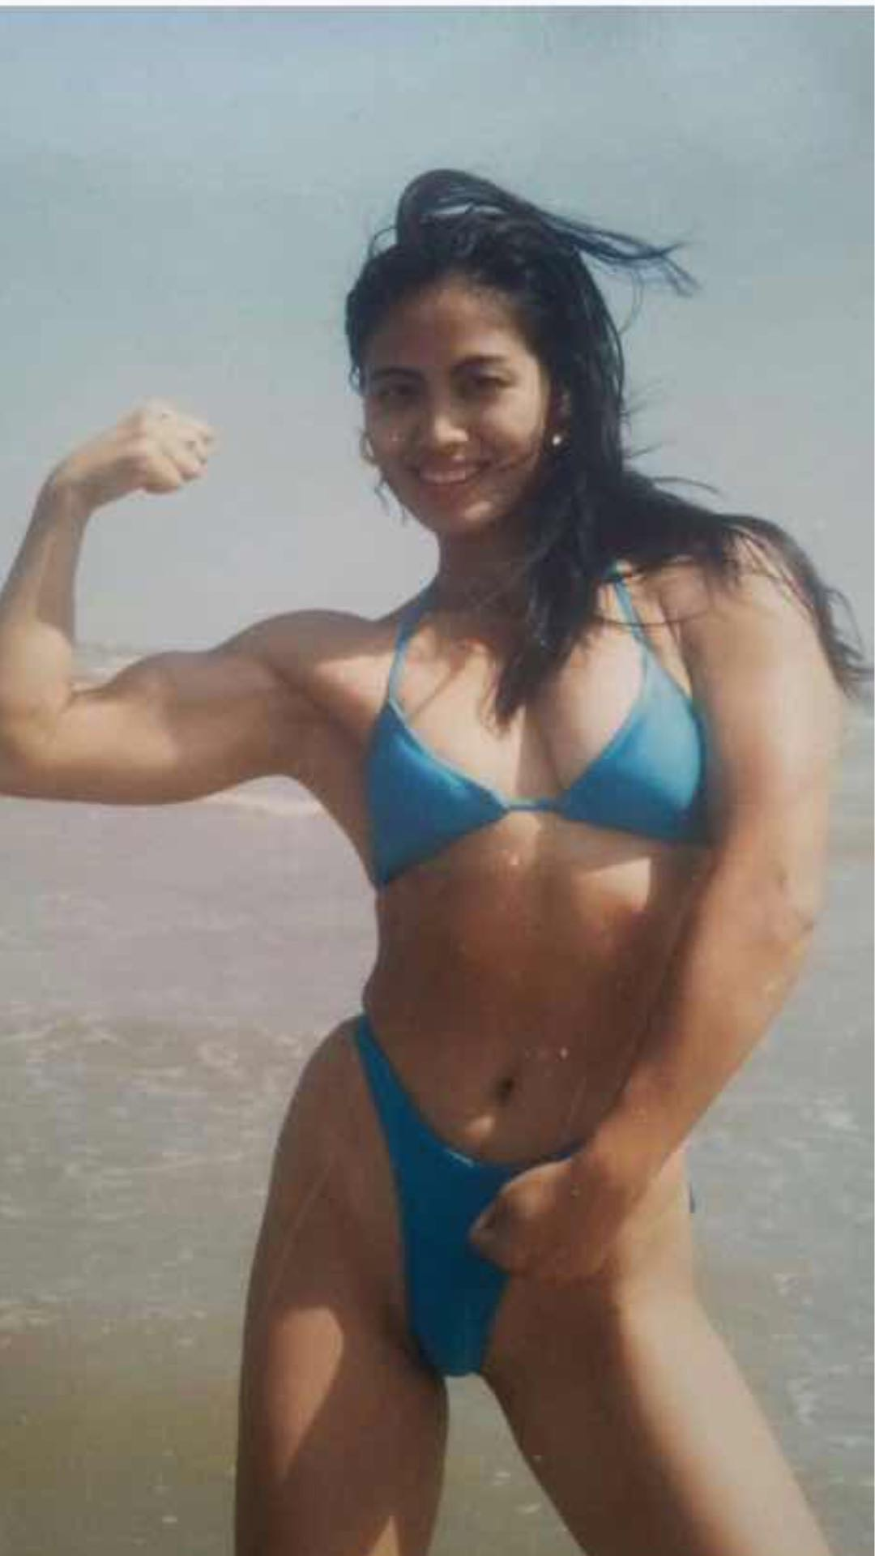
Instructor: Dr. Yuan Wei
Topic: Accurate Anatomy and Movement for Fu Needle 浮针中的精准肌肉运动（再罐注）
She graduated from the top university in sport, Beijing University of Sport. In 1990, she won the Champion of the National Award of the Chinese Body Building. Since then, she was famous in China. She started to learn natural medicine and got her license in German in 2006. She combines the body building with Fu needle, a kind of acupuncture just applying in the superficial area to gain a good result to release a lot of different type of pain, and healthy body tone. She teaches in this field more than two years.
浮针以安全速效而闻名，但患肌的精准再罐注是最重要的环节。主講魏媛自然療法醫師，是曾風雲全中國的健美冠軍，她畢業於北京體育大學，进修于科隆体育学院，兼修中醫藥和自然療法，現在德國從事自然療法醫師臨床。她對人體的每一塊肌肉如何運動健美、保健有非常特殊的心得。本次課程，她將浮針中的各個肌肉的精准運動（再罐注法）進行分析與示範教學。她將分享她運用浮針結合再罐注，對多種疼痛，特別是瘦身塑形的丰富经验。

【第一期回顧】
演講嘉賓：麻仲學博士
演講題目：康梭療法精準中醫抗癌系統的臨床應用
日期： 2019年11月18-19日
地點： 福特中醫大學東灣校區
報名：本課程已經結束
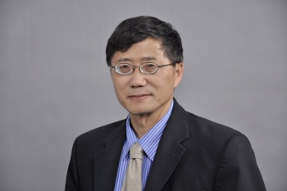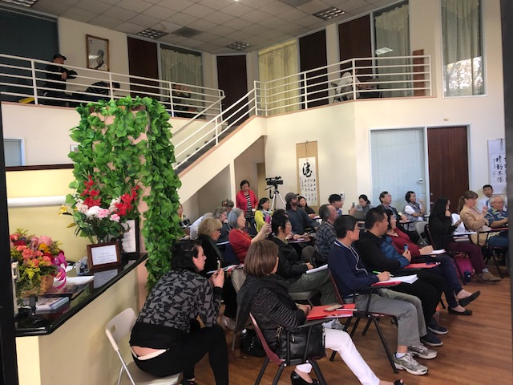

Silicon Valley Forum of Famous Doctors （ Phase Two and Three）
硅谷名醫大講堂（第二、三期）快速註冊表
Approved CEUs: LAc: 32 credits, Category 1, Provider #378

Phase Two (Chinese & German)
Instructor: Dr.Yuan Wei
Topic: Accurate Anatomy and Movement for Fu Needle
Date: December 9, 10, 2019
Phase Three (Chinese & English)
Instructor: Dr. Guojian Huang
Topic: Clinical Application of Mini -Ren Acupuncture Needle Therapy
Date: December 11, 12, 2019

Time: 9:30am to 6:30pm
Registration starts at: 8:00 am
Location: University of Herbal Medicine
2497-2499 Industrial Parkway West，Hayward, CA 94545

Fast Registration （ Please fill it out, take a picture, and send to 650 918 9968）
Name :
LAc#:
Email:
Phone :
Class Dates : Phase One Phase Two Both
type of card:
card number:
expiration: / , code : zip code

Fee: $388 for each phase; $676 for both phases (save $100)
Early Registration by December 6, 2019
$258 for 2 days; $466 for 4 days.
Call 650 350 1863
Or Text Message to 650 918 9968
email: consotherapy@gmail.com
Website: www.universityofherbalmedicine.org

